
Java 7 - Quick Sort - Detyra të zgjidhura & detyra për ushtrime
Lënda: Hyrje në Algoritme

Detyra 1: Te sortohet array a[ ]= 7, 5, 1, 3, 6, 4, 2 me quicksort Sedgewick 2 way partitioning.
Shuffled array: a[ ] = 5,3,1,7,4,2,6

5 3 1 7 4 2 6

Zgjidhje:

5 3 1 7 4 2 6 | 1) a[i] < a[lo]
lo i j | 3 < 5 (Po), i++

5 3 1 7 4 2 6 | 1) a[i] < a[lo]
lo i j | 1 < 5 (Po), i++

5 3 1 7 4 2 6 | 1) a[i] < a[lo] 2) a[j] > a[lo]
lo i j | 7 < 5 (Jo), 6 > 5 (Po), j--

5 3 1 7 4 2 6 | 2) a[j] > a[lo] 3) exchange a[i] me a[j]
lo i j | 2 > 5 (Jo),

5 3 1 2 4 7 6 | 1) a[i] < a[lo]
lo i j | 2 < 5 (Po), i++

5 3 1 2 4 7 6 | 1) a[i] < a[lo]
lo i j | 4 < 5 (Po), i++

5 3 1 2 4 7 6 | 1) a[i] < a[lo] 2) a[j] > a[lo]
lo i, j | 7 < 5 (Jo), 7 > 5(Po), j--

5 3 1 2 4 7 6 | i and j crossed, exchange a[lo] with a [j]
lo j i |

4 3 1 2 5 7 6 | first pivot

4 3 1 2 | 1) a[i] < a [lo]
lo i j | 3 < 4 (Po) i++

4 3 1 2 | 1) a[i] < a [lo]
lo i j | 1 < 4 (Po) i++

4 3 1 2 | 1) a[i] < a [lo]
lo i,j | 2 < 4 (Po) i++

4 3 1 2 | i and j crossed, exchange a[lo] with a [j]
lo j i |

2 3 1 4 | second pivot

Detyra 2: Te sortohet array a[ ] = 7,3,2,6,5,8,4 me quicksort Sedgewick 2 way partitioning.
Shuffled array: a[ ] = 6,3,7,2,8,5,4

6 3 7 2 8 5 4

Zgjidhje:

6 3 7 2 8 5 4 | 1) a[i] < a[lo]
lo i j | 3 < 6 (Po), i++

6 3 7 2 8 5 4 | 1) a[i] < a[lo] 2) a[j] > a[lo] 3) exchange a[i] me a[j]
lo i j | 7 < 6 (Jo), 4 > 6 (Jo)

6 3 4 2 8 5 7 | 1) a[i] < a[lo]
lo i j | 4 < 6 (Po), i++

6 3 4 2 8 5 7 | 1) a[i] < a[lo]
lo i j | 2 < 6 (Po), i++

6 3 4 2 8 5 7 | 1) a[i] < a[lo] 2) a[j] > a[lo]
lo i j | 8 < 6 (Jo), 7 > 6 (Po), j--

6 3 4 2 8 5 7 | 2) a[j] > a[lo] 3) exchange a[i] me a[j]
lo i j | 5 > 6 (Jo),

6 3 4 2 5 8 7 | 1) a[i] < a[lo]
lo i j | 5 < 6 (Po), i++

6 3 4 2 5 8 7 | 1) a[i] < a[lo] 2) a[j] > a[lo]
lo i,j | 8 < 6 (Jo), 8 > 6 (Po), j--

6 3 4 2 5 8 7 | i and j crossed, exchange a[lo] with a [j]
lo j i |

5 3 4 2 6 8 7 | first pivot

5 3 4 2 | 1) a[i] < a[lo]
lo i j | 3 < 5 (Po), i++

5 3 4 2 | 1) a[i] < a[lo]
lo i j | 4 < 5 (Po), i++

5 3 4 2 | 1) a[i] < a[lo]
lo i,j | 2 < 5 (Po), i++

5 3 4 2 | i and j crossed, exchange a[lo] with a [j]
lo j i |

2 3 4 5 | second pivot

Detyra 3. Te sortohet array a[ ] = 3,2,7,5,4,3,3,2 me quicksort Dijkstra 3 - way partitioning.
Shuffled array: a[ ] = 3,5,2,4,7,3,3,2

3 5 2 4 7 3 3 2
Zgjidhje:

3 5 2 4 7 3 3 2 | 1) 3 < 3 (Jo), 2) 3 > 3 (Jo), 3) 3==3 (Po) i++
lt,i gt |

3 5 2 4 7 3 3 2 | 1) 5 < 3 (Jo), 2) 5 > 3 (Po) exchange a[gt] with a[i], gt--
lt i gt |

3 2 2 4 7 3 3 5 | 1) 2 < 3 (Po), exchange a[lt] with a[i], i++, lt++
lt i gt |

2 3 2 4 7 3 3 5 | 1) 2 < 3 (Po), exchange a[lt] with a[i], i++, lt++
lt i gt |

2 2 3 4 7 3 3 5 | 1) 4 < 3 (Jo), 2) 4 > 3 (Po) exchange a[gt] with a[i], gt--
lt i gt |

2 2 3 3 7 3 4 5 | 1) 3 < 3 (Jo), 2) 3 > 3 (Jo), 3) 3==3 (Po) i++
lt i gt |

2 2 3 3 7 3 4 5 | 1) 7 < 3 (Jo), 2) 7 > 3 (Po) exchange a[gt] with a[i], gt--
lt i gt |

2 2 3 3 3 7 4 5 | 1) 3 < 3 (Jo), 2) 3 > 3 (Jo), 3) 3==3 (Po) i++
lt i,gt |

2 2 3 3 3 7 4 5 | i and gt cross, gjendet first pivot
lt gt i |

2 2 3 3 3 7 4 5 | first pivot
2 2 | 1) 2 < 2 (Jo), 2) 2 > 2 (Jo), 3) 2==2 (Po) i++
lt, i gt |

2 2 | 1) 2 < 2 (Jo), 2) 2 > 2 (Jo), 3) 2==2 (Po) i++
lt i,gt |

2 2 | i and gt cross, gjendet second pivot
lt gt i |

Detyra 3. Të sortohet vargu a[] = 48, 7, 35, 92, 14, 7, 6, 5, 27, 7, 48, 12, 99, 7, 5 duke përdorur algoritmin Quicksort - Dijkstra 3-way:
48 7 35 92 14 7 6 5 27 7 48 12 99 7 5

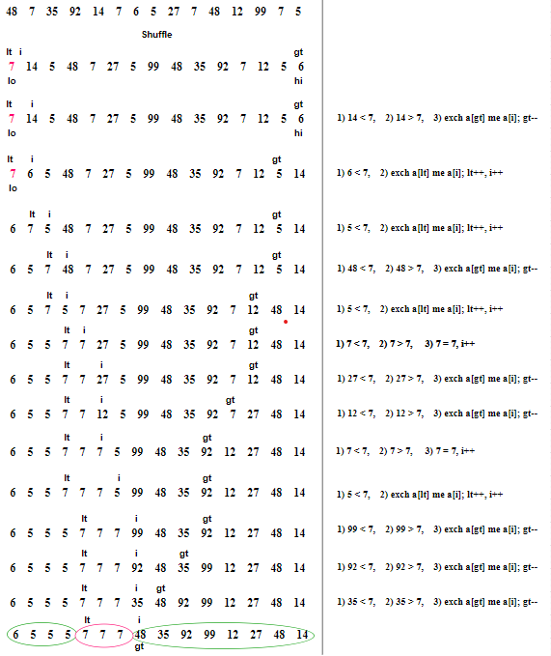
6 5 5 5 | 1) 5 < 6 (Po), exchange a[lt] with a[i], i++, lt++
lt, i gt |

5 6 5 5 | 1) 5 < 6 (Po), exchange a[lt] with a[i], i++, lt++
lt i gt |

5 5 6 5 | 1) 5 < 6 (Po), exchange a[lt] with a[i], i++, lt++
lt i,gt |

5 5 5 6 | 1) 5 < 6 (Po), exchange a[lt] with a[i], i++, lt++
lt,gt i | i and gt cross, pivot 2 found

Detyra për ushtrime

Detyra 1. Të sortohet vargu duke përdorur algoritmin Quick Sort - Sedgewick 2-way partitioning:
3 24 5 8 5 9 4 1 2 6
Detyra 2. Të sortohet vargu duke përdorur algoritmin Quick Sort - Sedgewick 2-way partitioning:
Q U I C K S O R T
Detyra 3. Të sortohet vargu duke përdorur algoritmin Quicksort - Dijkstra 3-way
P A B X W P P V P D P C Y Z
Detyra 4. Të sortohet vargu duke përdorur algoritmin Quicksort - Dijkstra 3-way
6 7 9 5 9 5 7 1 2 9

